51. EUROLOPPET GANGHOFERLAUF
A WEEKEND DEVOTED TO A JOINT SPORTING FESTIVAL
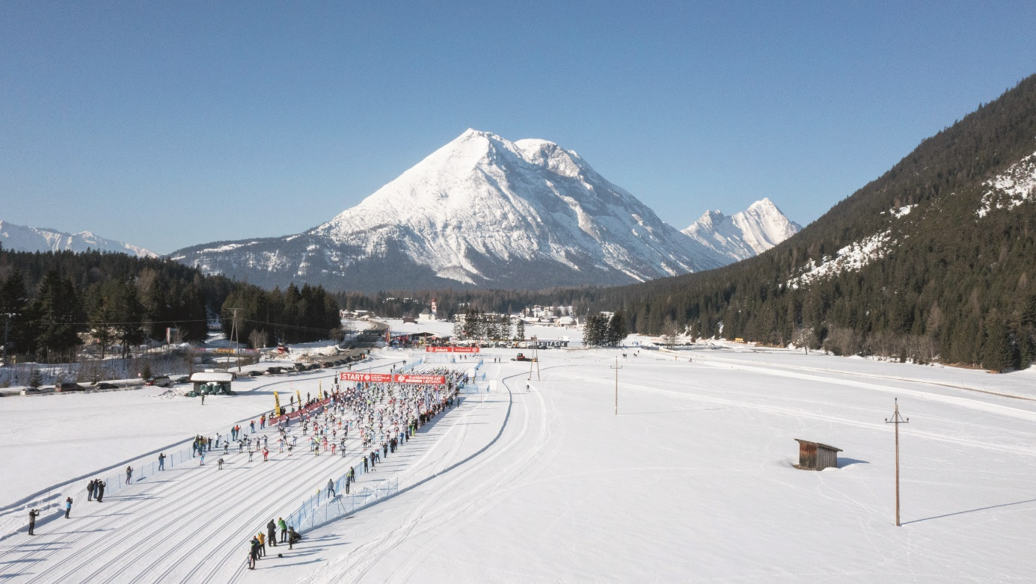

FINALLY TOGETHER AGAIN! The joy of finally celebrating another joint sports festival was written all over the faces of the participants, organisers and volunteers. On 05 and 06 March 2022 the athletes were welcomed and cheered on with great enthusiasm.
The legendary Ganghoferlauf was not only the last race before the first lockdown, but also the first public race to be held in Austria since the beginning of the pandemic. As if that alone wasn't reason enough for a truly brilliant sports festival, the 51st Ganghoferlauf thrilled everyone with impressive sporting moments and real top performances from young to old.

On Saturday morning the time had finally come, the wait was over: at exactly 9:00 a.m. the long-awaited starting signal was given for the 51st Ganghoferlauf in the classic style on the 25 and 50 km distance.
At the Specials and Mini Ganghoferlauf, the youngest runners celebrated the greatest sporting moments and were right up front with real sporting spirit and great motivation.
True to tradition, the skating competitions followed on Sunday with motivated amateur runners and ambitious professionals at the starting line. Punctually at 9:30 a.m. the first runners of the 20 km distance opened the race day, half an hour later the long distance followed as usual.
An extraordinary challenge was mastered by all the runners who competed in the 50 km classic on Saturday and the 42 km skating on Sunday. The outstanding performances were also recognised in a separate combined ranking.
A total of around 1500 participants delivered a tough but fair cross-country race at the 51st Ganghoferlauf. And even though the timekeepers had to choose the best times at the end, there were only happy winners in the Leutaschtal valley this weekend. For safety reasons, however, the really big sporting successes were celebrated on a smaller scale: with gastronomic vouchers for a favourite meal in an excellent regional restaurant of your choice.
PERFECT CONDITIONS - ENTHUSIASTIC FEEDBACK
Once again, Leutasch more than lived up to its premium Nordic image: as one of the most snow-sure places in Tyrol, the impressive Leutaschtal valley did not disappoint its participants. Under perfect conditions with top prepared, fast trails and lots of sunshine, the race was held on the traditional route and received correspondingly enthusiastic feedback among all participants.
TRULY SUCCESSFUL COOPERATION
The popular Ganghoferlauf in Leutasch was organised and held for the 51st time with the active support of more than 100 volunteers and a good 10 Leutasch clubs. Thanks to the excellent cooperation, after a year's break, we were finally able to welcome around 1500 participants to Austria's largest, oldest and most popular public run!

SAVE THE DATE
After this really successful Ganghoferlauf 2022 we are already looking forward to the next one! The 52nd Euroloppet Ganghoferlauf will take place from 04 to 05 March 2023.

THE WINNERS OF THE CLASSIC COMPETITIONS
25 KM Men  1. OLEX Max (01:02:05.7)  2. WAIDELICH Moritz (01:02:14.7)  3. BURGER Patrick (01:02:16.4) | 25 KM Women  1. DE BUHR Charlotta Sophie (01:11:14.2)  2. BECKER Linda (01:18:51.9)  3. ECKEL Johanna (01:19:39.9)
50 KM Men  1. MILZ Jakob (01:57:36.3)  2. AMHOF Manuel (01:57:36.8)  3. SUTTER Martin (02:03:30.9) | 50 KM Women  1. MÜLLER Franziska (02:16:02.8)  2. SCHMIDHOFER Anna (02:23:19.1)  3. STEWART Brand (02:49:14.6)

THE WINNERS OF THE SKATING COMPETITIONS
20 KM Men  1. NÄFF Noe (47:09.9)  2. NÄFF Isai (47:10.6)  3. SCHUBERT Felian (47:27.6) | 20 KM Women  1. ZINECKER Lisa (49:44.1)  2. HUTH Lou (49:45.4)  3. BERCHTOLD Jasmin (52:29.9)
42 KM Men  1. OLEX Max (1:33:57.6)  2. MILZ Jakob (1:33:59.8)  3. WEISHÄUPL Andreas (1:34:00.8) | 42 KM Women  1. MUTSCHELLER Sigrid (1:37:50.6)  2. KUEN Julia (1:39:12.6)  3. SCHMIDHOFER Anna (1:44:21.4)

THE WINNERS OF THE COMBINED RANKING (long distance classic & skating)
Men  1. MILZ Jakob (3:31:35)  2. KUCHL Johannes (3:43:45)  3. WEBER Hannes (4:05:49) | Women  1. SCHMIDHOFER Anna (4:07:40)  2. STEWART Brandy (4:52:13)  3. KUNER Isabell (4:56:35)

The winners of all long distances are also the Visma winners.
All results can be found HERE.

More information: www.ganghoferlauf.at

You can download royalty-free images HERE. Photo credits according to the copyright notice of the photo. Reprint free of charge.
For further questions:
Olympiaregion Seefeld, c/o Lisa Krenkel | Kirchplatzl 128a, 6105 Leutasch |
+43 664 2509613 oder lisa.krenkel@seefeld.com | www.seefeld.com

